

**AIU-VT Joint Training Program  
Final Report**

* + **Project Name:**   
    Sobek Transit.
  + **Project Location:**   
    Hybrid (Online + one week on AIU Campus).
  + **Companies:**   
    - Alamein International University (AIU) .  
     *New Alamein City, Matrouh Governorate, Egypt.*  
    - Virginia Tech (VT).  
     *Blacksburg, VA, USA.*
  + **Mentors:**   
    - Dr. Islam Elgedawy (AIU Side).   
     Contact: [Ielgedawy@aiu.edu.eg](mailto:Ielgedawy@aiu.edu.eg)  
    - Dr. Mohammed Seyam (VT Side).   
     Contact: [Seyam@vt.edu](mailto:Seyam@vt.edu)
  + **Training Duration:**  
     Jan 2023 - May 2023 (4 months).
  + **Team Members:**  
    - Youssef Badreldin (AIU Side) “20100294”.  
    - Muhammad Soliman (AIU Side) “20100245”.  
    - Keshav Bhateja (VT Side) .

Table of Contents

**Abstract** 3

**Introduction** 4

**Problem** 6

**Solution** 7

**Project Research** 8

**Business Model** 11

**Project Charter** 12

**Goals** 13

**Success Measures** 13

**Working Agreements** 13

**Personas** 14

**User Stories** 15

**Story Tasks and Prioritization list** 17

**Estimations** 20

**Burnup Charts** 21

**System Architecture Design** 23

**Testing Approach** 27

**Results** 30

**Evaluations** 32

**Retrospections** 32

**Recommendations** 32

**Conclusion** 33

**Links** 34

**Presentation Slides** 34

**Demo** 34

**Acknowledgement Letters** 35

# **Abstract:**

The project aims to develop an efficient and user-friendly online transit system for the students, faculty, and administration of AIU. The system will provide a range of services, including bus tracking, student registration, payment integration, route information, and feedback collection. By implementing this system, the goal is to enhance the overall transportation experience, optimize resource allocation, and improve communication between users and administrators. The project will involve collaboration with a third-party transportation company, AIU representatives, and the AIU transport unit. The development process will include extensive user input, iterative design releases, and testing to ensure a seamless and reliable application. The system's unique features include real-time bus tracking, user ratings for drivers, and data analytics to drive improvements. While there are existing systems, they often suffer from usability issues, inaccurate information, or lack of support. In contrast, the proposed system aims to address these shortcomings by providing accurate and up-to-date information and user-friendly interfaces. The project will be implemented first as a web application with the possibility of expansion into iOS and Android applications. The success of the project will be measured based on user adoption, positive ratings, and financial viability. The initial business model includes a service fee for transactions, covering operational costs and app store fees. Marketing efforts will involve leveraging AIU communication channels and physical promotions. The project team possesses relevant skills in web and mobile app development, and additional skills will be acquired as needed. Overall, the proposed online transit system aims to revolutionize the transportation experience for AIU stakeholders and create a reliable and efficient platform for daily commuting.

# **Introduction:**

The purpose of this project report is to present a comprehensive overview of the development and implementation of an online transit system for the students, faculty, and administration of AIU. This introduction provides an overview of the project's background, objectives, scope, and significance.

In today's fast-paced world, efficient transportation systems are crucial for educational institutions to ensure smooth commuting for their members. Recognizing the need to enhance the transportation experience at AIU, this project aims to develop a user-friendly and technologically advanced online transit system. The system will streamline various aspects of transportation, including bus tracking, student registration, payment integration, route information, and feedback collection.

The primary objectives of this project are to improve the overall transportation experience, optimize resource allocation, and enhance communication between users and administrators. By achieving these goals, the project will contribute to increased efficiency, reduced waiting times, and improved satisfaction among the AIU community.

Existing transportation systems often face challenges such as usability issues, inaccurate information, and limited support. In contrast, the proposed online transit system aims to address these shortcomings by providing accurate and up-to-date information, user-friendly interfaces, and excellent customer support.

Collaboration with a third-party transportation company, AIU representatives, and the AIU transport unit will be crucial for the successful development and implementation of the system. The project team will prioritize user input, incorporating feedback and suggestions throughout the development process. This iterative approach ensures that the final application meets the specific needs and preferences of the AIU community.

The development of the online transit system will initially focus on the implementation of a reliable web application, with potential future expansion to iOS and Android. The system's key features include bus tracking, user ratings for drivers, and data analytics to drive continuous improvements. These features will enable users to have a more reliable and transparent transportation experience.

To gauge the success of the project, various metrics will be considered, including user adoption rates, positive ratings, and financial viability. A sustainable business model has been devised, incorporating service fees for transactions to cover operational costs and app store fees.

This project report outlines the project's vision, goals, scope, success measures, and working agreements. It provides an overview of the development tasks and prioritization list, covering aspects such as bus tracking, authentication, bus route information, online booking, and weather/bus updates. Additionally, the report presents an estimated timeline for the project's development, including key milestones and deliverables.

By revolutionizing the transportation experience for AIU stakeholders, this online transit system aims to create a reliable and efficient platform for daily commuting. The report delves into the technical details of the system's development, emphasizing the significance of this project in enhancing the overall experience and satisfaction of the AIU community.

# **Problem:**

The current AIU transportation system lacks quality and reliability. The problems can be classified into the following points:

**1. Limited communication and feedback between parties:** The AIU system lacks a reliable channel for communication between users and the AIU transport unit (drivers and administrators). Students and administrators have to rely on channels such as WhatsApp groups or direct calls to administrators or bus drivers to stay updated about the bus location. This method is inefficient and time-consuming. Furthermore, there is no channel for users to provide feedback or rate the drivers, which hinders opportunities for improvement and accountability.

**2. Manual booking and payment process:** The current system requires users to make manual payments through the finance office for daily tickets or through physical bank transactions for semester fees. This process is time-consuming and highly inefficient.

**3. Inaccurate trip information:** The existing system fails to provide accurate trip information regarding bus stops, estimated arrival times at certain stops, or any changes caused by emergencies, road issues, or inclement weather.

**4. Lack of user interface and user experience (UI/UX):** The current system is outdated and lacks interfaces for users to interact with. Consequently, there is no user experience to build upon or improve.

# **Solution:** **User-Friendly Web Application:** Developed a user-friendly web application with an intuitive interface for easy navigation and accessibility, empowering users to access transportation-related information and services seamlessly.

**Google Maps Integration:**

Integrated Google Maps to visually display bus stops, routes, and the entire transportation network, allowing users to explore different routes, view bus stop locations, and effectively plan their trips using the interactive map.

**Driver Information and Ratings:**

Implemented a comprehensive driver management system that displays driver profiles, including their names, license plate numbers, and ratings. Users can make informed decisions by viewing driver ratings and select their preferred drivers for a more personalized transportation experience.

**Secure Authentication with Google OAuth:**

Incorporated Google Authentication (Google OAuth) to enhance the security and convenience of user logins. Users can securely log in to the web app using their Google accounts, ensuring privacy and reducing the need for separate account creation.

**Seamless Booking and Payment Process:**

Streamlined the booking process by allowing users to select routes, confirm trip details, and proceed to a secure payment page. Integrated PayMob as the payment gateway to facilitate smooth and reliable online payments for a hassle-free transaction experience.

**Trip Information and Updates:**

Provided accurate and up-to-date trip information, including bus schedules and estimated arrival times. Users can stay informed about their trips, reducing uncertainties and improving their overall transportation experience.

**Feedback Collection and Incident Reporting:**

Implemented a feedback system within the web app to collect user feedback and ratings for drivers and the transportation service. Enabled users to report incidents or issues they encountered during their trips, ensuring accountability and facilitating continuous improvements.

**API Integration for Driver Information:**

Developed an API to retrieve and display comprehensive driver information in real-time. Users can access the latest driver data, ensuring they have reliable and updated information to make informed choices

# **Project Research:**

**1. What service(s) will the system provide?**

The system will provide the following services:

- Keeping track of buses running and the number of students traveling in each bus.

- Allowing users to rate drivers.

- Enabling payment through the app.

- Providing information on route stops and timings.

- Storing information regarding transactions, buses running, and students traveling.

- Optimizing transportation resources by calculating the number of buses needed for each route and the number of students traveling through each route to avoid wastage of resources.

**2. Who are the main stakeholders and end users?**

The main stakeholders are:

- The third-party transportation company.

- AIU representative to the transportation company.

- AIU transport unit.

The end users are:

- Bus drivers.

- Students traveling to and from the university.

- AIU transport unit members responsible for financials and student registration.

**3. How are you going to find users to communicate with throughout the design and development of the project?**

To communicate with users during the design and development phases, a mass survey will be sent out to gather user feedback and feature requests. Small releases will be implemented, incorporating these features one by one. Selected users who filled out the form will have access to the website and be able to test the app on their mobile devices.

**4. Who are the potential users that you have access to?**

The potential users include:

- Students, faculty members, and other AIU staff traveling from Alexandria, Cairo, and other locations to and from the university.

- Users who currently rely on communication methods like a WhatsApp group or calling the driver for bus updates.

**5. What communities is the system going to serve? What demographics? What locations?**

The system will serve the student population (17-23 years of age), faculty members, and AIU administrative and other staff (26-65 years of age). The main locations served are Alexandria, Cairo, Mansoura, Behira, and Damanhour.

**6. How are you going to solicit user input in the initial phases of analysis and design?**

Extensive user feedback will be collected through a dedicated form on the website and the app. The form will gather data on various factors, including ease of use, speed, user-friendliness, and effectiveness of the application.

**7. What is "new" about the system? Is it the idea of it, or is it the way it approaches a solution that already exists?**

The system introduces a bridge between users and drivers/administrators to create and manage seamless bookings. Users will be able to track buses, access information on different bus stops, link their payment methods to the app, rate drivers, and administrators will gain useful insights about the transportation system to improve it. The system aims to provide a reliable channel of operation.

**8. What are the other systems that have goals similar to your system (mention some examples)? What criticism do you have about them? How do you think your system will be different?**

Examples of similar systems are Blacksburg Transit, Salek, and Sobek Transit. Blacksburg Transit suffers from incorrect stop information, a slow-loading app, and lack of support. Salek has a difficult signup process and a laggy application with no clear way to purchase packages. Sobek Transit aims to provide accurate bus route information through satellite view, real-time updates, and a user-friendly app. Our system will differentiate itself by providing a seamless user experience, accurate and timely information, ease of payment integration, driver rating, and a focus on user feedback for continuous improvement.

**9. What platform(s) will your app support?**

The app will be accessible through most internet browsers running a JavaScript engine. It will primarily support iOS devices, including Macbook, iPhone, iPad, Apple Watch, and Apple TV. There is a possibility of supporting Android devices as well.

**10. If your system is an app, why does it have to be a mobile app (not a desktop or a web application)?**

A mobile app is preferred over a desktop or web application because it offers user-specific information, such as trip details and payments, in a more convenient and accessible manner. The majority of the target users, including students and AIU faculty, have smartphones, making it easier for them to access the app quickly. The mobile app also enables features like recommendations based on trip history, real-time bus location updates, and estimated arrival times, which are most beneficial on a mobile platform.

**11. What are the data, ML, and algorithmic aspects of the proposed system?**

The proposed system will handle data related to financial transactions, user information (including unique IDs, payment types, buses used, and travel dates), bus routes, information about bus stops, and any route changes due to construction or holidays. Machine learning algorithms can be utilized to analyze user behavior and provide insights for system improvement. Algorithms for optimizing bus allocation and resource management can also be implemented.

**12. How are you going to test your system (prototypes and final product)?**

The website and app will undergo rigorous testing by the developers. SwiftUI testing framework will be used for the app, while Jest will be used to test API endpoints and JavaScript code. Users will have the ability to provide crash reports and feedback through the website and app.

**13. What software tools will be needed for app development? What skills does your team currently have, and what skills still need to be acquired?**

The software tools needed for app development include Xcode, VSCode, Postman, Heroku, and Github. The team currently possesses skills in SwiftUI, HTML, CSS, JavaScript, React, Jest, Node.js, and MongoDB. Skills that still need to be acquired include Java for Android development, SwiftUI kits, Jest, and SwiftUI testing.

**14. How do you think your app will generate revenue? What is the initial business model? What are your initial thoughts for marketing the app?**

The app will generate revenue by charging a service fee of 10% for each transaction, with a potential increase during high demand (not exceeding 20%). This service fee will cover database and API deployment costs, as well as the app store's yearly fee.

For marketing, initial plans include in-house marketing efforts, such as publications in the AIU voice club, AIU website, and physical posters around campus. Posters on buses and bus stops will also help attract users to the app.

**15. What skills do your team members have to work on this system? What skills are missing, and how do you plan to obtain them?**

The team has expertise in web development, mobile apps, and graphic design. They have the advantage of direct communication between AIU administrators and developers, enabling effective collaboration. The team will provide valuable feedback, as most members will also be end users of the appTo fill any missing skill gaps, the team plans to utilize a mix of Scrum and XP approaches, embracing change and focusing on small releases for continuous user feedback. They will also invest time in learning the Scrum process and implementing practices like pair programming and daily scrum meetings.

# **Business Model:**

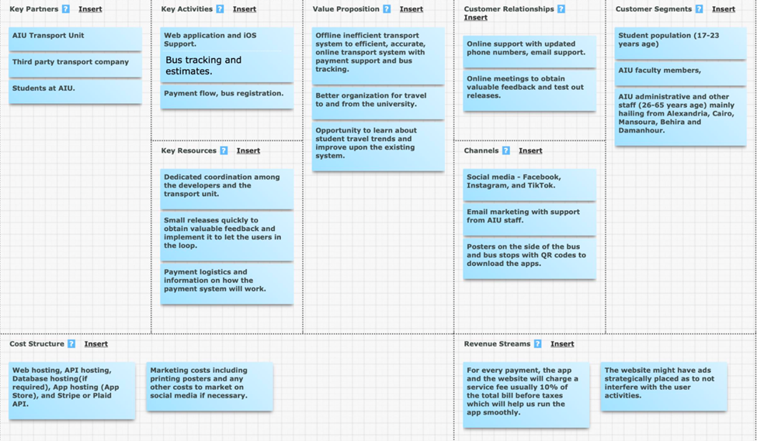

# **Project Charter: ● Vision**

An efficient, easy-to-use, user-friendly online transit system utilized by the students, faculty, and administration at AIU as an integral part of their daily lives. The system aims to provide users with peace of mind when traveling to and from the university.

**● Goals**

○ Develop a fully functional web and mobile application that prioritizes excellent user experience and provides accurate information about the transit system.

○ Ensure reliable and prompt support, including cancellation assistance available 24 hours in advance.

○ Implement a system that allows multiple buses to operate based on user data, as the current system only utilizes one bus at specific times, resulting in wasted time for students and faculty members.

○ Provide stakeholders with valuable user data and financial information to understand user behaviors and enable the provision of better and more profitable services in the future.

**● Scope**

○ In-Scope

- Payment system for online booking and cancellation support.

- Estimated arrival and departure times for different buses.

- Timely updates regarding unforeseen circumstances or bus route changes.

- Availability of seat information and route details.

○ Out-of-scope

- Live tracking of buses (due to the installation cost of hardware).

- Offline support for bus route information (automated messaging or calling).

- Development of an Android application (due to time constraints).

**● Values**

Embrace Change: Willingness to promptly implement user feedback and continuously improve the system.

Quick software releases and maintenance of web hosting.

Encouraging deep collaboration between users and stakeholders.

# **Goals:**

**Goals achieved:**

● Functional web app focused on a user-friendly UI and providing information about the transit system.

● Storage and retrieval of multiple bus route information from the database.

● Collection of valuable user data regarding bus route history for stakeholders.

**Goals not achieved:**

● Accurate information about the transit system and seat availability.

● Presentable user data for stakeholders and bus drivers.

● Bus booking system to notify drivers.

● Insufficient information about the number of buses to make a meaningful improvement to the existing system.

# **Success Measures:**

○ 10 buses carrying 280 students, fully operating using the app with registration, payment, and tracking system.

○ Achieving 300 user hits on the website and 100 app downloads on iOS devices.

○ Receiving a rating of 4.5+ on the App Store and obtaining good reviews to be published on the website.

○ Promoting the project in the AIU Voice Club, Facebook, Newsletter, and local radio.

# **Working Agreements:**

○ Commitment to the values stated above.

○ Clear communication regarding availability and skill experiences to delegate work properly.

○ Committing to internal deadlines and being patient with colleagues.

○ Respecting personal and work boundaries due to the time difference.

# **Personas:**

# 

# **User Stories:**

1. As a student, I want to be able to easily view the bus routes and schedules, so that I can plan my trips to and from the university accordingly.

2. As a faculty member, I want to have access to real-time bus tracking, so that I can see the current location of the bus and estimate its arrival time at the bus stop.

3. As a student, I want to be able to book my bus tickets online and make payments securely, so that I can avoid the hassle of manual booking and payment processes.

4. As an administrator, I want to be able to manage the bus routes and schedules, so that I can ensure efficient and timely transportation services for the AIU community.

5. As a student, I want to be able to rate the drivers based on their performance and provide feedback, so that the transportation service can continuously improve and address any issues.

6. As a user, I want to receive timely updates and notifications about any changes or disruptions in the bus routes or schedules, so that I can adjust my travel plans accordingly.

7. As a student, I want to have a user-friendly interface and intuitive navigation in the Sobek Transit app, so that I can easily access the information and services I need without any confusion.

8. As a user, I want to have a seamless and reliable experience while using the Sobek Transit app, so that I can trust the system and rely on it for my daily commuting needs.

9. As a faculty member, I want to be able to track the bus occupancy and availability of seats, so that I can plan my trips and ensure a comfortable commuting experience.

10. As an administrator, I want to have access to user data and analytics to analyze the usage patterns, preferences, and satisfaction levels of the transportation system, so that I can make data-driven decisions for improvements.

11. As a student, I want to be able to view my booking history and easily rebook previous tickets, so that I can save time and effort when making future bookings.

12. As a user, I want to have a reliable and secure payment system integrated into the Sobek Transit app, so that I can make online payments for my bus tickets without any concerns.

13. As an administrator, I want to be able to communicate important announcements and updates to the users through the Sobek Transit app, so that they are informed about any changes or relevant information.

14. As a student, I want to be able to view the bus capacity and available seats in real-time, so that I can plan my trips and choose buses that have sufficient seating capacity.

15. As a user, I want to have a feedback mechanism in the Sobek Transit app, so that I can provide suggestions, report issues, or share my overall experience with the transportation service.

16. As a faculty member, I want to be able to view historical data and reports about the transportation service, such as the number of trips, average occupancy, and user ratings, so that I can evaluate the effectiveness and performance of the system.

17. As an administrator, I want to have the ability to update and modify bus routes, schedules, and other relevant information in real-time, so that I can respond to any changes or requirements promptly.

18. As a user, I want to have access to a help and support section in the Sobek Transit app, so that I can find answers to frequently asked questions or seek assistance if needed.

19. As a student, I want to be able to synchronize my bus ticket information with my calendar or set reminders, so that I can stay organized and never miss a bus.

20. As a faculty member, I want to be able to generate reports and analyze data related to transportation expenses and usage, so that I can manage and allocate resources effectively.

# **Story Tasks and Prioritization list:**

**Show**

- Provide the correct number of seats for the corresponding bus.

- Update the number of seats with every online ticket purchase.

- Reset the bus seats every day, except for weekly and monthly tickets.

- Ensure the bus information is correct for each driver and every bus.

- Rate the correct driver based on the ticket purchased by the user.

- Require users to provide a brief description of their experience for low ratings.

**Estimated Bus Tracking System - 75**

- Ensure the bus stops for each bus are correct and regularly updated.

- Maintain the bus tracking system within an error range of +-10 mins.

- Update bus tracking every 15 minutes with a new position if the bus has changed.

- Update any discrepancies or changes on the route on the system within 30 mins.

- Display the correct bus route and stops on the map for each bus.

- Update all buses based on the day they are running and any altered hours.

- Adjust bus routes and times accordingly if a bus is delayed for any reason.

**Login/Authentication - 3**

- Detect existing or new email addresses and redirect users to the appropriate page.

- Ensure only one student is registered with one aiu.edu email address.

- Enforce strong password requirements (8 characters with uppercase, lowercase, number, and symbol).

- Verify student registration and eligibility by uploading and correctly detecting the university ID and student ID number.

**Bus Route Information - 5**

- Verify the accuracy of the bus route information with bus drivers to ensure correct marking on the map.

- Update the information on holidays and rush days.

**Online Booking - 75**

- Verify student registration at the university.

- Verify the correctness of card details using Luhn's Algorithm.

- Avoid time conflicts between different bus tickets.

- Limit each student to two bus tickets.

- Record the time of ticket purchase for allowing alterations 24 hours prior.

**Number of seats in the bus and the ability to rate the driver - 25**

- Update the available seats on the bus correctly.

**Updated Weather/Bus information - 20**

- Ensure timely updates (within 30 minutes) of any changes in route or itinerary due to weather or unforeseen circumstances such as road closings or flat tires.

- Correctly update the emergency dialog box on the website.

***Tasks:***

**Show**

- Implement a JavaScript-based API. (6 hours)

- Deploy the system on Heroku/Railway. (1 hour)

- Use MongoDB database. (1 hour)

- Apply authentication for different endpoints. (4 hours)

- Use Jest/Postman to test endpoints. (5 hours)

- Design HTML/CSS for a user-friendly view of the data. (1 hour)

- Request location timestamp from the user to estimate bus timings more accurately. (2 hours)

**Estimated Bus Tracking System - 75**

- Create a user-friendly map displaying all bus stops and bus routes. (7 hours)

- Update the location of buses on the map every 15 minutes. (1 hour)

- Develop an HTML/CSS/JavaScript website to present the requested bus data. (1 hour)

- Implement a user-friendly drop-down menu for selecting different buses and viewing their information. (1 hour)

- Retrieve location timestamps every 15 minutes to keep the bus location updated. (1 hour)

**Login/Authentication - 3**

- Design a user-friendly interface (HTML/CSS) to facilitate the registration process. (1 hour)

- Implement authentication for users using OAuth 2.0. (2 hours)

- Check password strength using HTML. (1 hour)

**Bus Route Information - 5**

- Create a user-friendly map displaying all bus stops and bus routes. (7 hours)

- Update the location of buses on the map every 15 minutes. (1 hour)

- Implement authentication for driver and bus data. (2 hours)

- Include the number of seats in the bus and enable rating of the driver. (25)

**Online Booking - 75**

- Integrate Stripe or Plaid API with correct banking information. (4 hours)

- Integrate Luhn's algorithm if required. (1 hour)

- Limit users to two bus tickets: one to the university and one from the university, considering previously bought tickets for the day. (2 hours)

- Save the history of purchased tickets on the app and enable quick rebooking of previous tickets. (2 hours)

**Updated Weather/Bus information - 20**

- Display pop-up messages in case of problems indicating who should be called. (1 hour)

- Show pop-up messages in case of closed streets or street conditions that could delay the trip. (1 hour)

# **Estimations:**

|  |  |  |  |
| --- | --- | --- | --- |
| FEATURES | Round 1 | Round 2 | Round 3 |
| Estimated Tracking System | Y-75,K-50,S-75 | Y-75,K-75,S-75 |  |
| Login/Authentication | Y-1,K-20,S-20 | Y-1,K-3,S-3 | Y-3,K-3,S-3 |
| Online Booking and Cancellation | Y-75,K-100,S-50 | Y-75,K-75,S-75 |  |
| Updated Bus Information and Weather Updates | Y-20,K-50,S-20 | Y-20,K-20,S-20 |  |
| Number of seats in the bus | Y-50,K-20,S-20 | Y-20,K-20,S-20 |  |
| Bus routes | Y-5,K-50,S-1 | Y-5,K-5,S-5 |  |
| Rate driver | Y-1,K-1,S-5 | Y-1,K-1,S-1 |  |

***(Youssef - Y , Keshav - K , Soliman – S)   
<Weightage - 1,3,5,10,20,50,75,100>***

**Prioritization of the stories:-**  
  
1. Estimated tracking system - Rate Driver (Noura) - First Sprint

2. Login/Authentication - Noura, Liad, Khairy

3. Bus Routes - Ziad

4. Number of seats - Ziad, Khairy

5. Online Booking - Khairy

6. Updated bus information - Ziad

# **Burnup Charts:**

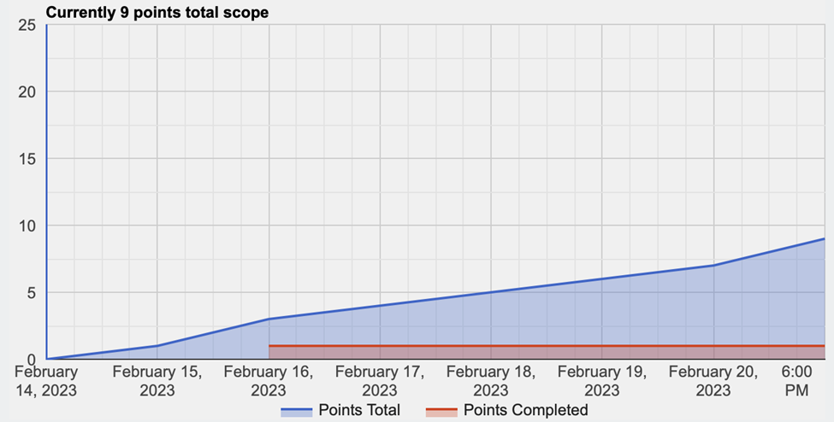

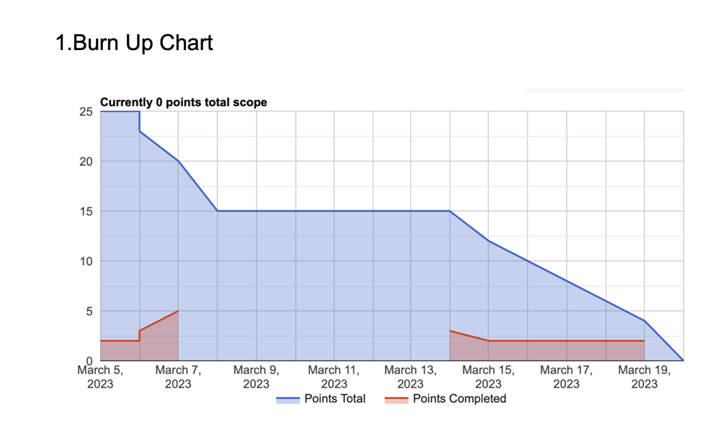  
  
  
  
  
  
  
  
  
  
  
  
  
  
  
  
  
  
  
  
  
  
  
  
  
  
  
  
  
  
  
  
  
  
  
  
  
  
  
  
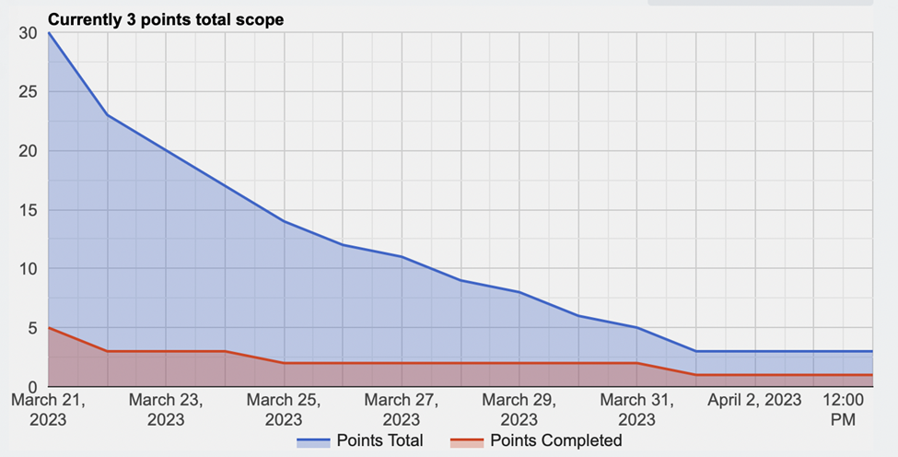  
  
  
  
  
  
  
  
  
  
  
  
  
  
  
  
  
  
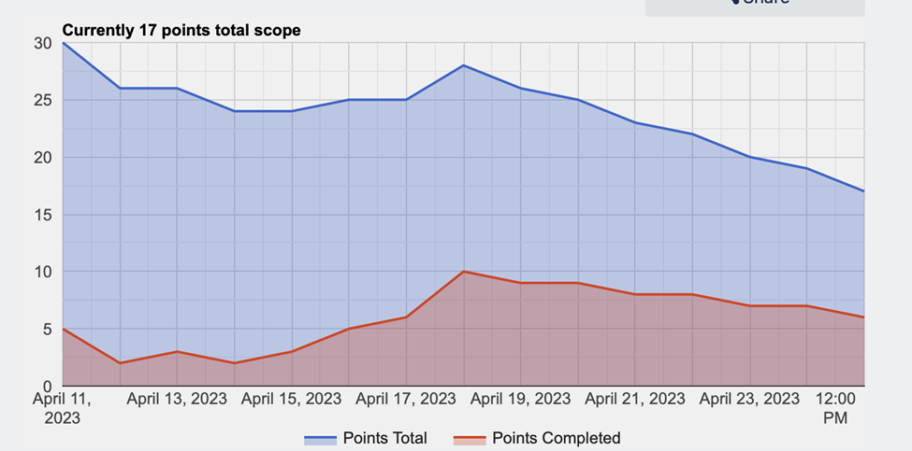

# **System Architecture Design:**

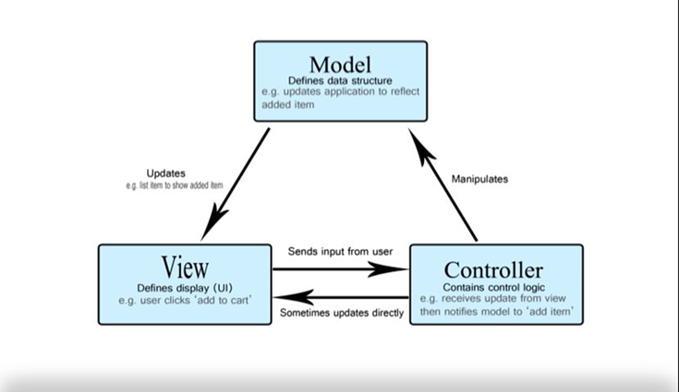

We used MVC because we saw it as the best fit for our project, as it will help us make our code more reusable, as it keeps everything organized and clean.

It also offers a lot of flexibility in designing (adding and removing components)

Also, it will help in the testing phase since each component will be separated and will be tested individually.

**Architecture diagram (level 0):**

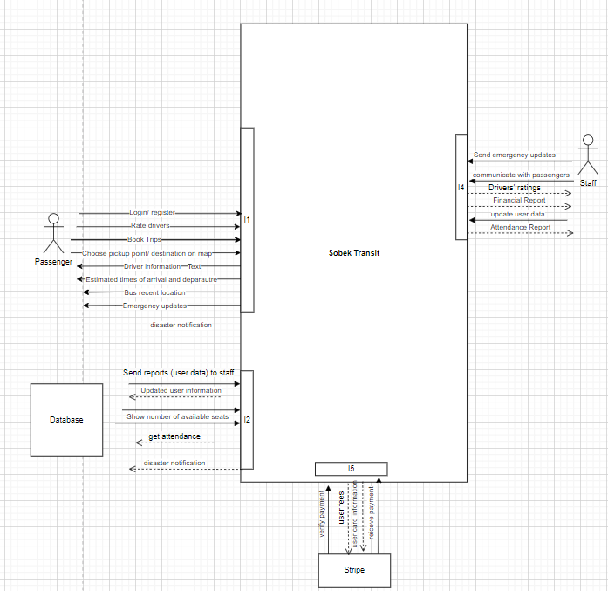

**Use case diagram:**

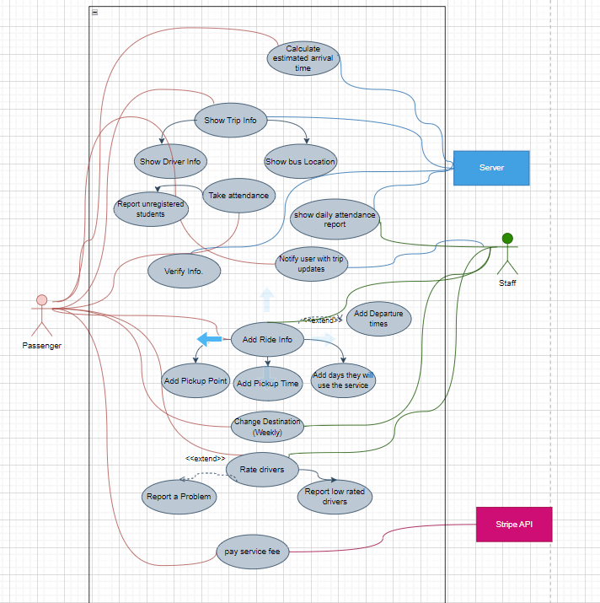

**Class diagram:**

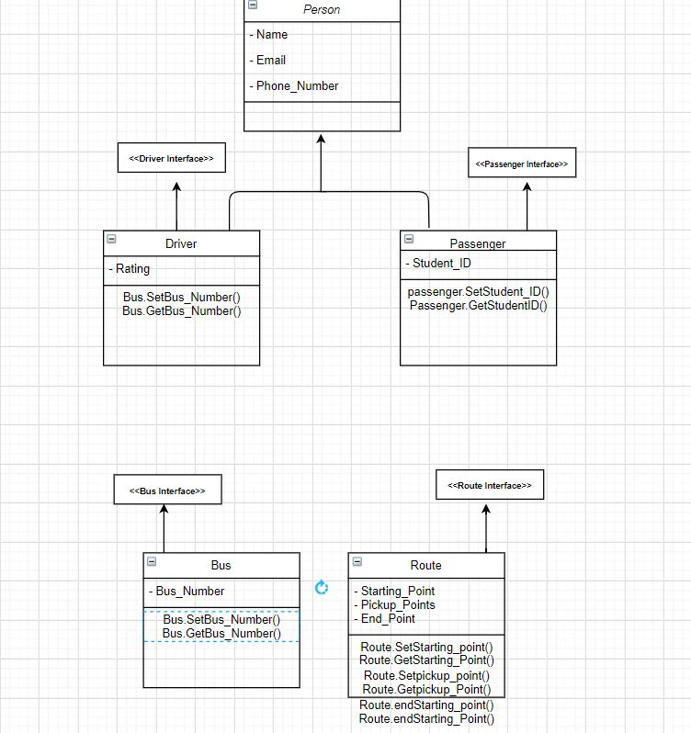

**ERD diagram:**

**Sequence diagram:  
  
  
  
  
  
  
  
  
  
  
  
  
  
  
  
  
  
  
  
  
  
  
  
  
Testing Approach:**

In the project, we employed both smoke testing and feedback-based testing methodologies to ensure software stability and meet the needs of our users.

Smoke Testing: It is a basic functionality check conducted early in the software development life cycle to identify major issues or defects.

Feedback-Based Testing: This approach emphasizes gathering feedback from users or stakeholders to identify issues or defects in the software and enhance its quality.

# **Results:**

The development and implementation of the Sobek Transit online transit system for AIU have been successful in achieving key milestones and delivering essential features to enhance the overall transportation experience for AIU students, faculty, and administrators. The system has undergone rigorous testing and evaluation, and the following results have been obtained:

1. User-Friendly Web Application: The web application has been developed with a user-friendly interface, allowing users to access transportation-related information and services seamlessly. The application has undergone testing to ensure its functionality and ease of use.

2. Google Maps Integration: The integration of Google Maps has provided visual displays of bus stops, routes, and the entire transportation network. Users can explore different routes, view bus stop locations, and effectively plan their trips using the interactive map.

3. Driver Information and Ratings: The comprehensive driver management system displays driver profiles, including names, license plate numbers, and ratings. Users can make informed decisions by viewing driver ratings and select their preferred drivers for a more personalized transportation experience.

4. Secure Authentication with Google OAuth: The implementation of Google Authentication (Google OAuth) has enhanced the security and convenience of user logins. Users can securely log in to the web application using their Google accounts, ensuring privacy and reducing the need for separate account creation.

5. Seamless Booking and Payment Process: The booking process has been streamlined, allowing users to select routes, confirm trip details, and proceed to a secure payment page. Integration with PayMob as the payment gateway facilitates smooth and reliable online payments for a hassle-free transaction experience.

6. Trip Information and Updates: Accurate and up-to-date trip information, including bus schedules and estimated arrival times, has been provided to users. Users can stay informed about their trips, reducing uncertainties and improving their overall transportation experience.

7. Feedback Collection and Incident Reporting: A feedback system has been implemented within the web application to collect user feedback and ratings for drivers and the transportation service. Users can report incidents or issues encountered during their trips, ensuring accountability and facilitating continuous improvements.

8. API Integration for Driver Information: An API has been developed to retrieve and display comprehensive driver information in real-time. Users can access the latest driver data, ensuring they have reliable and updated information to make informed choices.

The Sobek Transit system has undergone evaluations and retrospections to assess its performance and identify areas for improvement. The system has achieved several of its intended goals and success measures, including the development of a functional web application, integration of essential features, and positive user feedback. However, there are areas where the system fell short of its goals, such as achieving the intended number of operational buses and user hits on the website.

The project team has made recommendations based on the evaluations and retrospections to address the identified shortcomings and improve the system further. These recommendations include setting rigid internal deadlines, maintaining regular communication, and reorganizing to ensure progress and success.

Overall, the Sobek Transit system has made significant progress in revolutionizing the transportation experience at AIU. The system's development and implementation have provided a reliable, efficient, and user-friendly platform for daily commuting, enhancing the overall transportation experience for AIU stakeholders.

# **Evaluations:**

● Instead of 10 buses, we only have operational route information for 5 buses.

● There were 36 user hits on the website, excluding repeated visits.

● Promotion in the AIU voice club was implemented.

● App Features: User-friendly UI that works, authentication, booking system, route information for 5 buses and their routes on Google Maps, and a feedback system.

● Measures not achieved: Intended user hits, bus information for 10 buses, and a booking system that updates drivers.

# **Retrospections:**

**Things which went well:**

● Having a clear idea of what the final product should look like.

● Conducting honest evaluations of each other's abilities.

● Dividing tasks effectively.

● Promptly assisting each other when someone needs help.

● Maintaining a healthy working environment and practicing patience with everyone.

**Things which didn't go well:-**

● Meeting internal deadlines and achieving weekly targets.

● Experiencing communication gaps and irregular updates.

● Neglecting the maintenance of the Trello board and hesitating to ask for help when needed.

● Struggling to find a regular meeting time due to changing commitments.

# **Recommendations:**

● Set rigid internal deadlines and meet more often than you think.

● Be honest about your progress and ask for help whenever needed.

● Reorganize and reflect on success measures frequently.

# **Conclusion:**

In conclusion, the development and implementation of the Sobek Transit online transit system for AIU have made significant strides towards addressing the shortcomings of the existing transportation system. The project has successfully achieved key milestones and delivered a range of essential features that enhance the overall transportation experience for AIU students, faculty, and administrators.

Through the development of a user-friendly web application with intuitive interfaces, Sobek Transit offers users seamless access to transportation-related information and services. The integration of Google Maps provides a visually appealing and interactive experience, allowing users to explore different routes, view bus stop locations, and plan their trips effectively.

The comprehensive driver management system, which includes driver profiles, ratings, and other relevant information, empowers users to make informed decisions and personalize their transportation experience. The incorporation of secure authentication with Google Oauth ensures convenient and secure user logins, while the seamless booking and payment process, powered by PayMob, streamlines transactions and reduces friction for users.

Accurate trip information, including bus schedules and estimated arrival times, enhances user convenience and reduces uncertainties. The feedback collection system and incident reporting feature promote accountability and provide a mechanism for users to share their experiences and contribute to continuous improvements in the transportation service.

The development of an API for real-time driver information retrieval enables users to access the latest driver data, ensuring they have reliable and updated information for making informed choices.

While the Sobek Transit system continues to evolve, the progress achieved thus far demonstrates the commitment and dedication of the project team, under the guidance of Dr. Mohammed Seyam from Virginia Tech (VT). The collaborative efforts and iterative design releases have ensured that user feedback and suggestions have been incorporated into the development process, resulting in a more tailored and user-centric application.

Looking ahead, it is crucial to continue refining and expanding the Sobek Transit system, addressing any remaining tasks, and further optimizing its performance. The success of the project will be measured by user adoption rates, positive ratings, and feedback, and its ability to improve transportation efficiency and user satisfaction.

In conclusion, the Sobek Transit project holds great promise in revolutionizing the transportation experience at AIU. By addressing the limitations of the current system and providing a user-friendly and technologically advanced platform, Sobek Transit aims to create a reliable, efficient, and seamless transit experience for AIU stakeholders. With continued efforts and ongoing collaboration, the Sobek Transit system is poised to positively impact the AIU community, enhancing daily commuting and fostering a more connected campus environment.

# **Links:**

**Github:**

<https://github.com/keshavbhateja/SobekNew>

**Trello:**

<https://trello.com/b/pXTlCnae/sobek-transit>

**Heroku**:  
<https://sobektransit.herokuapp.com>

# **Presentation Slides:**

[Sobek Transit Final Presentation](https://docs.google.com/presentation/d/1krjmARHCFcuUWmV9b9Dy7m_oA25Lhw-LUZGFCHvwXk4/edit#slide=id.p)

# **Demo:**

[LINK](https://drive.google.com/drive/folders/1Suxvy6Io9MHkJ8xIrv3pl0QkunlYDzYJ?usp=sharing)

# **Acknowledgement Letters:**

